|  |  |
| --- | --- |
| cetlogo ***CHEMICAL ENGINEERING TRANSACTIONS***  ***VOL. xxx, 2025*** | A publication of  aidiclogo_grande |
| The Italian Association  of Chemical Engineering  Online at www.cetjournal.it |
| Guest Editors: Bruno Fabiano, Valerio Cozzani  Copyright © 2025, AIDIC Servizi S.r.l. **ISBN** 979-12-81206-xx-y; **ISSN** 2283-9216 | |

Numerical Modelling Of The Behaviour Of Walls And Doors Of 20 Ft ISO Containers Through Real-Scale Explosion Tests

Seyth Amouzoua, Guillaume Lecocq*a*, Benjamin Le Roux*a,* Emmanuel Leprette*a*, Jos Planchard*a,,* StéphaneCharrondièrea & Laurent Mathieua

aINERIS Verneuil-en Halatte, France

ISO containers are more and more used to shelter processes involving a potential explosion risk such as Battery Energy Storage Systems or hydrogen-based systems. With such systems, the containment can potentially lead to a risk of accumulation of flammable gases, which can result in explosions. An important part of the modelling strategy for predicting residual pressure effects of an internal explosion in an ISO container is the knowledge of the mechanical resistance of this structure subjected to blast load. In this context Ineris carried out hydrogen explosions tests in 20-foot ISO containers. The purpose was to collect comprehensive measurements related to the mechanical behaviour of the doors and walls. These complement other tests in the literature (Atanga et al., 2019) which have focused mainly on the explosion pressure inside the container. In parallel Ineris have developed a specific finite element numerical model using LS-DYNA software capable of predicting the dynamics response of a container – walls and doors – subjected to an internal explosion.

The paper details the description of the numerical model and focuses on the comparison between simulations and tests in terms of displacements, strain and stresses levels as well as failure modes and opening time of the door.

* 1. Introduction

As part of the energy transition, the development of alternative energies sources is leading to the use of containerised applications for which containers may house batteries, storage tanks or energy generation devices, for example. These cases can accidentally lead to leaks and accumulation of flammable gases in the container followed by an explosion if an ignition source is present. Containers may be protected by vents against the pressure effects of an explosion. To understand the factors influencing the vented explosion process, numerous experimental and numerical studies have been carried out over the last few decades. Several researchers have studied vented hydrogen deflagrations. The influence of various parameters such as H2 concentration, ignition location, homogeneity of the flammable mixture and vent surface areas has been analysed (Rui et al., 2021). For the 20-foot containers, the HySEA project (improving Hydrogen Safety for Energy Applications) focused mainly on the explosion phenomenon, but few studies have focused on the mechanical response (Rui et al., 2020). These studies focused on the evaluation of maximum displacement as function of pressure using empirical assumptions of side wall. This approach is based on the elastic behaviour of the structure and does not take into account the non-linear mechanical behaviour. Skjold et al, 2019 carried out more than 60 explosion tests in a 20 ft container. The study essentially focused on pressure field measurement (8 pressure gauges) rather than on the response of the container side wall. Only the lateral displacement in the center of each side wall was measured with lasers.

In addition to the various experimental works, numerical modelling has also been carried out in the literature to study the behaviour of containers submitted to an internal explosion. Most studies have decoupled the explosion modelling and the structural response using the CFD (Computational Fluid Dynamics) technique for modelling the explosion (Skjold et al., 2019) and finite elements for the structure (Pini et al., 2019). Atanga et al. 2019 proposed a semi-coupled CFD-EF simulation method of the explosion and the dynamic response of the 20-ft container. In this latest study, the numerical modeling focuses exclusively on the behaviour of the side wall and the measurement of laser displacement at the center of a side wall. Finite element models tend to underestimate the maximum displacement of the side wall compared to the experimental measurements.

However, in most of the experiments described in the literature, containers were not extensively instrumented. This does not allow to understand accurately their mechanical behaviour and validate numerical models. To better understand the mechanical response of the 20-foot container to internal explosion, Ineris carried out an experimental campaign consisting in producing different internal pressure signals in several containers through hydrogen explosions (Lecocq et al., 2024). This series of tests was extensively instrumented using various measurement techniques such as lasers, numerous strain gauges, accelerometers and high-speed cameras for image correlation and scan.

The present paper aims to present a finite element model, using LS-DYNA software, of the walls and door of the 20-foot container and comparison with the results of the explosion tests performed by Lecocq et al., 2024.

* 1. Description of the experimental work

This chapter describes briefly the experimental work presented with more detailed in (Lecocq et al., 2024). Five explosion tests were carried out on three second-hand standard 20-foot containers (6 m x 2.5 m x 2.5 m). The tests were carried out with H2-air mixtures of varying concentrations, ranging from 14 to 22% by volume. Two preliminary tests with low explosion severity (~14% vol. H2) were performed to calibrate the experimental set-up and fix the ignition location (close to the ground or close to the vent). A 1m² opening was cut in the roof and covered with a plastic sheet to reduce the explosion pressure. In order to avoid any projections in case of the walls breaking or the doors being ripped off, steel cables surrounded the container without preventing its deformation. The doors were initially kept closed by their fixing bars. The container was supported on two concrete columns at the rear to prevent it from moving backwards.

The container was instrumented with six pressure sensors, four accelerometers, twenty strain gauges (longitudinal and transverse) and a laser to measure displacement at the middle of a side wall. Two high-speed cameras offering different viewing angle were also used for image post-processing by stereo-correlation. The containers were scanned before and after explosions to assess their state of damage.

pressure probes

Figure 1: Experimental set-up.

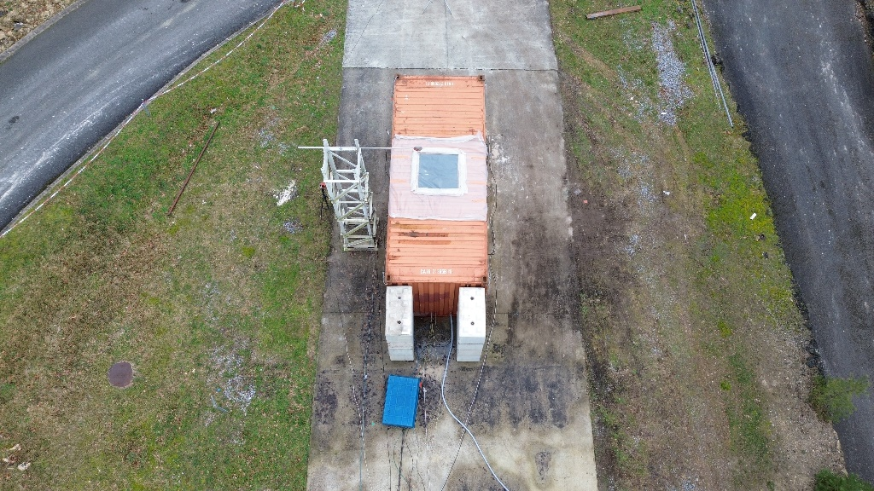

Vent

Concrete columns

Figure 2a: Location of strain gauges. - Figure 2b: Vent location on the roof.

The table below summarizes the results of the three explosion tests.

Table 1: Summary of the results of the explosion tests

|  |  |  |  |  |  |  |
| --- | --- | --- | --- | --- | --- | --- |
| Test | [H2]  (% vol.) | Pmax  (mbar) | Dwall  (mm) | Dresidual  (mm) | Im  (bar.ms) | Comments |
| 03 | 20 | 530 | 450 | 255 | 39,26 | Doors opening (at 170-180 ms) and low plastic deformation of the side walls and the roof |
| 04 | 22 | 780 | 530 | - | 40,23 | Doors opening (at 150-155 ms), medium deformation of the side walls and the roof, tear at the junction between a side wall wall and the roof |
| 05 | 20 | 440 | 420 | 293 | 36,26 | Doors opening (at 178-180 ms) and low plastic deformation of side wall and on roof |

H2: concentration hydrogen, Pmax: Maximum pressure, Dmax: Maximum displacement in center of the side wall, Dresidual: Residual displacement in center of the side wall, Im: Pressure impulse

The results of test 5 are presented together with the numerical results in section 3.

* 1. Development of a numerical model of the mechanical behaviour of 20-foot containers
     1. Modelling assumptions

The walls of the containers and the doors have been modelled separately in order to reduce the size of the model elements and optimise the calculation time. It is assumed that the behaviour of the doors has minimal influence on the rest of the structure, and vice versa, as it seems to be indicated by the high-speed video analysis. Shell elements were used in the LS-DYNA software to model the side walls and roofs. The implicit-explicit functionality in LS-DYNA enables the modelling of material behaviour up to failure, accounting for the dynamic nonlinear response associated with large deformations. Considering the symmetry of the container, half of it was modelled to reduce calculation time. The ground is modelled as a rigid wall (Figure 3b). The contact with the concrete column at the rear is modelled by a simple support boundary condition.

This section presents the strategy adopted for modelling the structural response of the 20-foot container.

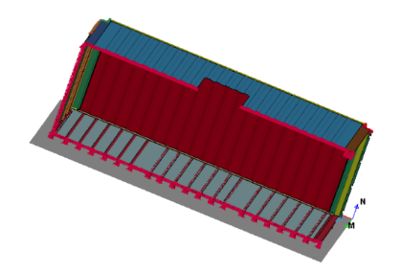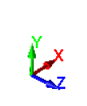

Floor concrete

Ux=Ry=Rz=0

Uz=0

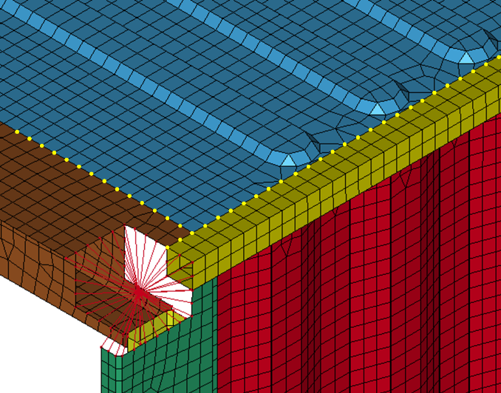

Uy=0

Figure 3a: Plane of symmetry - Figure 3b: EF model of the container showing the cut on the roof

The material law chosen in the LS-DYNA database for the S355 walls and door is the Mat 15 law. This latter uses the Johnson-Cook damage criteria (Forni et al., 2016).

Table 2: Parameters of the Johnson-Cook's law

|  |  |  |  |  |
| --- | --- | --- | --- | --- |
| Material | A[MPa] | B[MPa] | n | C |
| S355 | 448 | 782 | 0.562 | 0,0247 |

The pressure loading considered in this simulation is an overpressure signal applied homogeneously to all the walls of the container (Figure 4).

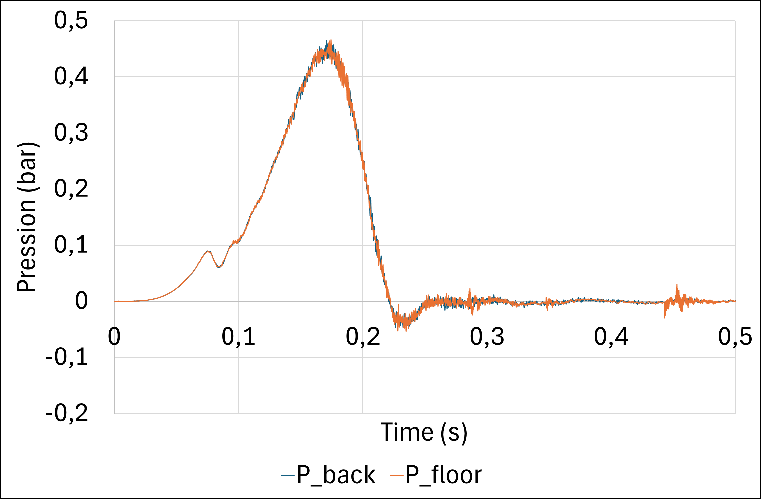

Figure 4: Measured overpressure in the container for test 5.

A calibration was performed to determine the optimal characteristic cell width for mesh convergence, a width of 10 mm providing accurate results.

* + 1. Results of the simulation of the side walls behaviour

The figures below show the comparative results of the simulation and the results of test 5 in terms of overall deformations.

Displacement of the side wall (FE model).

modelled container

du container testé

Deformation of the

modelled container.

du container testé

Deformation of the

real container.

du container testé

Figure 5a: Figure 5b: Figure 5c:

The comparison shows that the numerical deformations match those of the container tested (Figure 5). The simulation reproduces well the permanent wall deformations profiles, as well as the profiles of the displacement and deformation curves in the center of the side wall. However, the model overestimates the experimental maximum displacement by 10% (Figure 6).

Figure 6: Comparison curve for experimental-numerical displacement

at the center of the side wall.

|  |  |
| --- | --- |
|  |  |
| Figure 7a: Comparison curve for experimental-numerical strain cross Gauge 3 (located at the center of the side wall). | Figure 7b: Comparison curve for experimental-numerical longitudinal strain Gauge 4 (located at the center of the side wall). |

The strain comparison curves exhibit the same temporal trends in strain at the center of the side wall in the numerical simulation compared to the test (see Figure 7a and Figure 7b). It should be noted that the numerical maximum strains slightly overestimate the experimental data by approximately 37% (Figure 7a) and 7% (Figure 7b). These numerical results confirm the reliability of the modeling assumption, and the Johnson-Cook damage criteria parameters used.

To complete the analysis of the overall deformation of the side wall, a comparative evaluation was conducted between the scan image of the side wall after test and the corresponding predicted deformation.

|  |  |  |
| --- | --- | --- |
|  | Une image contenant conteneur maritime, conteneur de fret, conteneur, rouge  Description générée automatiquement  B  A |  |
| Figure 8a: Deformation of the real side wall. | Figure 8b: Scan image of the side wall. | Figure 8c: Numerical deformation of the side wall. |

The comparison of the scan images of the side walls and the numerical simulation shows a good match in terms of permanent deformation profiles. The residual displacement values measured on the scan images and obtained with the modelling in different points of the side wall are approximately equivalent. For example, at point A (resp. B): the measured displacement is 186 mm (resp. 240 mm) and the modelled one is 89 mm (resp. 283 mm), which corresponds to a relative difference of 2% (resp. 15 %).

* + 1. Assumptions for modelling the door behaviour

The same modelling strategy has been adopted for the door with details of door components such as fixing bars, hinges and anchors.

The entire door frame is constructed as a shell element as a rigid body with a characteristic cell width of 30 mm. The walls and elements fixed by screws (beam element) are deformable bodies with a cell width of 10 mm. In contrast to the modelling of the walls, the fixing bars are modelled as 4-node tetrahedral solid elements.

* + 1. Results of the simulation of the door behaviour

The figures below show the results of the comparison of the door opening sequences between the numerical modelling and the results of test 5. The doors are modelled using the same load as shown in Figure 4.

|  |  |  |
| --- | --- | --- |
| Une image contenant conteneur de fret, train  Description générée automatiquement avec une confiance moyenne |  |  |
| Figure 9a: t=0 ms. | Figure 9b: t=180 ms. | Figure 9c: t=299 ms. |
| anchors  Fixing bars  Fixing hinges |  |  |
| Figure 10a: t=0 ms | Figure 10b: t=180 ms | Figure 10c: t=299 ms |

The figures below show the comparison of the experimental and calculated strains for gauges 13 and 24. (Locations shown in Figure 2a).

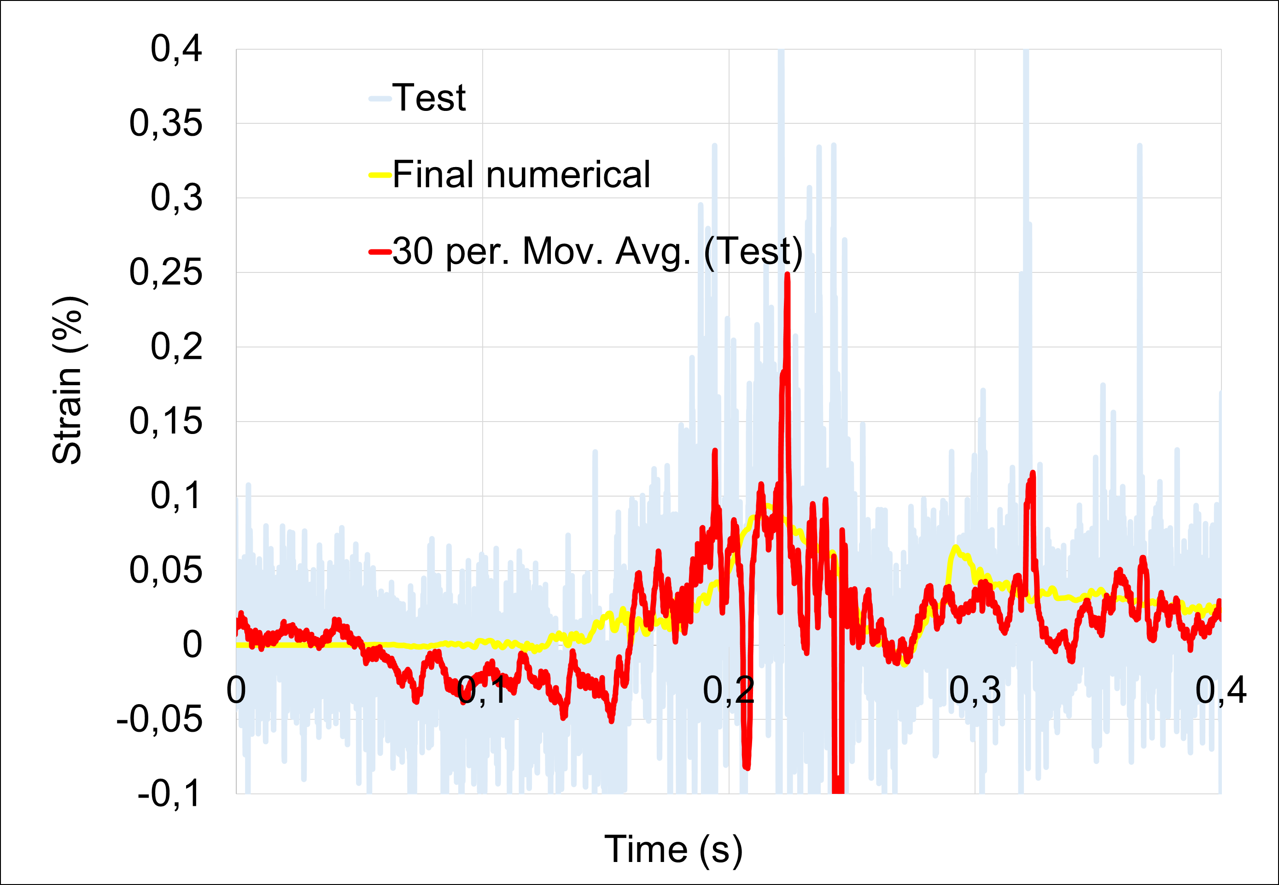 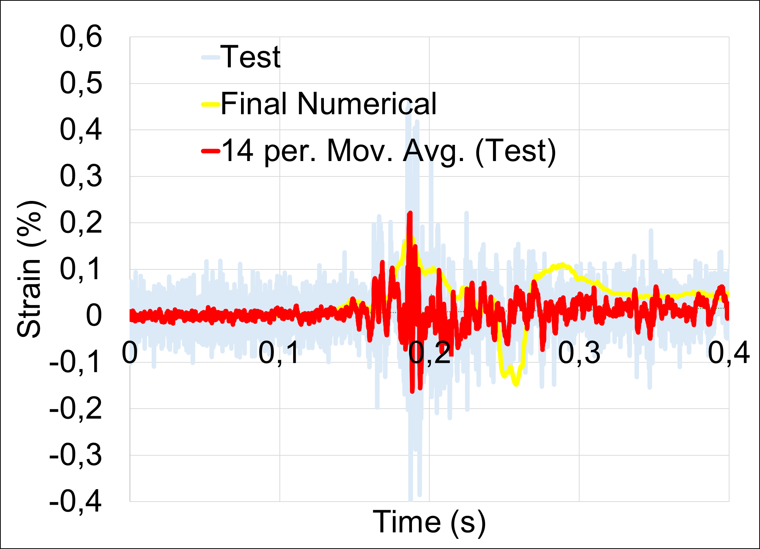

Comparison curve for experimental

(gauge)-numerical strain Gauge 13

Comparison curve for experimental

(gauge)-numerical strain Gauge 24

.

Figure 11a: Figure 11b:

The comparison shows a good correlation between the experimental and numerical results. Overall, the same opening sequences are found experimentally and numerically, revealing the factors facilitating the door opening, in particular the fixing bars The opening sequences of the doors started at approximately the same instant, around 180 ms (Figures 9 and 10). However, it should be noted that the numerical strains slightly overestimate the experimental data by approximately 5% (Figures 11a and 11b). A comparison of the scan and numerical results, similar to the one carried out for the side walls, was made for the door. Analogous damages were observed in center of the door, with residual displacement values about 105 mm for the Scan and 99 mm for the numerical results. The relative difference between experimental and numerical values is approximately 6%.

* 1. Conclusion

A finite elements numerical model of the 20-foot container's response to internal explosion has been developed.

The comparison of the numerical model with the experimental data. in terms of deformations shows good agreement. This modelling provides access to more extensive complete and comprehensive information for analyzing the deformation and damage of a container subjected to an internal explosion. These models will continue to be improved by incorporating for example openings corresponding to the locations of ventilation grids. The development of a full-scale modeling of the container (walls and door) will also allow to better account for interdependencies between its elements.

This numerical simulation allows to evaluate other scenarios, assess the damage state, and the integrity of container without the need for costly tests. Such a model can also be used as a basis for developing a meta-model for constructing P-I vulnerability diagrams and helping to improve the design of explosion vents.

* 1. References

Atanga G., Lakshmipathy S., Skjold T., Hanssen A.G., 2019, Structural response for vented hydrogen deflagrations: Coupling CFD and FE tools. International Journal of Hydrogen Energy 44, 8893-8903

Forni D., Chiaia B., Cadoni E., Strain rate behaviour in tension of S355 steel: Base for progressive collapse analysis. Engeering Structures 119,164-173

Lecocq G., Amouzou S., Leprette E., Le Roux B., Charrondière S., Mathieu L.,2024, Study of the behaviour of walls and doors of 20 ft ISO containers through real-scale explosion tests. 15th International Symposium on Hazards, Prevention, and Mitigation of Industrial Explosions

Pini T., Hanssen A.G., Schiavetti M., Carcassi., 2019, Small scale experiments and Fe model validation of structural response during hydrogen vented deflagrations, International Journal of Hydrogen Energy 44, 9063-9070

Rui S., Wang C., Luo X., Jing, Li. Q., 2013, External explosions of vented hydrogen-air deflagrations in a cubic vessel, Fuel 301, 121023

Rui S., Wang C., Wan Y., Luo X., Zhang Z., Li Q., 2020, Experimental study of end-vented hydrogen deflagrations in a 40-foot container. International Journal of Hydrogen Energy 45, 15710-15719

Skjold T., Hisken H., Lakshmipathy S., Atanga G., Bernard L., van Wingerden M., Olsen K.L., Holme M.N., Turøy N.M., Mykleby M., van Wingerden K., 2019, Vented hydrogen deflagrations in containers: Effect of congestion for homogeneous and inhomogeneous mixtures, International Journal of Hydrogen Energy 44, 8819-883